1 run......

Downloading: 100%

411/411 [00:00<00:00, 14.7kB/s]

Downloading: 100%

263M/263M [00:11<00:00, 23.8MB/s]

training 1 epoch...

138.56236028671265 seconds used......

1 training finished! average train loss: 0.8504630367910496

evaluating...

Confusion matrix, without normalization

[[ 0 9 115]

[ 0 76 88]

[ 0 11 854]]

Normalized confusion matrix

[[0. 0.07258065 0.92741935]

[0. 0.46341463 0.53658537]

[0. 0.01271676 0.98728324]]

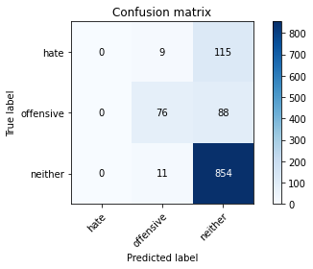

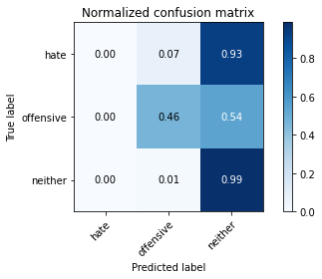

/opt/conda/lib/python3.7/site-packages/sklearn/metrics/_classification.py:1245: UndefinedMetricWarning: Precision and F-score are ill-defined and being set to 0.0 in labels with no predicted samples. Use `zero_division` parameter to control this behavior.

_warn_prf(average, modifier, msg_start, len(result))

/opt/conda/lib/python3.7/site-packages/sklearn/metrics/_classification.py:1245: UndefinedMetricWarning: Precision and F-score are ill-defined and being set to 0.0 in labels with no predicted samples. Use `zero_division` parameter to control this behavior.

_warn_prf(average, modifier, msg_start, len(result))

/opt/conda/lib/python3.7/site-packages/sklearn/metrics/_classification.py:1245: UndefinedMetricWarning: Precision and F-score are ill-defined and being set to 0.0 in labels with no predicted samples. Use `zero_division` parameter to control this behavior.

_warn_prf(average, modifier, msg_start, len(result))

precision recall f1-score support

hate 0.00 0.00 0.00 124

offensive 0.79 0.46 0.58 164

neither 0.81 0.99 0.89 865

accuracy 0.81 1153

macro avg 0.53 0.48 0.49 1153

weighted avg 0.72 0.81 0.75 1153

average eval_loss: 0.5955183793758524, accuracy: 0.8065915004336514

training 2 epoch...

137.58786821365356 seconds used......

2 training finished! average train loss: 0.7453677193500076

evaluating...

Confusion matrix, without normalization

[[ 60 17 47]

[ 21 103 40]

[104 31 730]]

Normalized confusion matrix

[[0.48387097 0.13709677 0.37903226]

[0.12804878 0.62804878 0.24390244]

[0.12023121 0.03583815 0.84393064]]

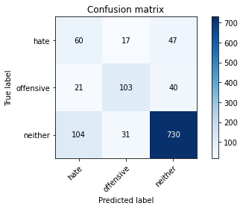

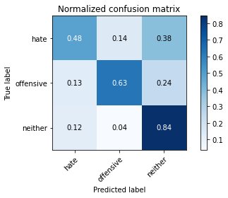

precision recall f1-score support

hate 0.32 0.48 0.39 124

offensive 0.68 0.63 0.65 164

neither 0.89 0.84 0.87 865

accuracy 0.77 1153

macro avg 0.63 0.65 0.64 1153

weighted avg 0.80 0.77 0.79 1153

average eval_loss: 0.6413180812679488, accuracy: 0.7745013009540329

training 3 epoch...

137.61834859848022 seconds used......

3 training finished! average train loss: 0.635569734479787

evaluating...

Confusion matrix, without normalization

[[ 28 10 86]

[ 9 90 65]

[ 44 25 796]]

Normalized confusion matrix

[[0.22580645 0.08064516 0.69354839]

[0.05487805 0.54878049 0.39634146]

[0.05086705 0.02890173 0.92023121]]

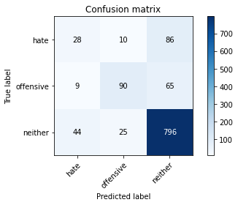

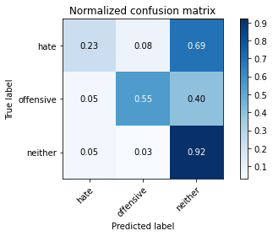

precision recall f1-score support

hate 0.35 0.23 0.27 124

offensive 0.72 0.55 0.62 164

neither 0.84 0.92 0.88 865

accuracy 0.79 1153

macro avg 0.64 0.56 0.59 1153

weighted avg 0.77 0.79 0.78 1153

average eval_loss: 0.5800727944949577, accuracy: 0.792714657415438

training 4 epoch...

137.51842164993286 seconds used......

4 training finished! average train loss: 0.432177669715149

evaluating...

Confusion matrix, without normalization

[[ 85 6 33]

[ 48 89 27]

[312 21 532]]

Normalized confusion matrix

[[0.68548387 0.0483871 0.26612903]

[0.29268293 0.54268293 0.16463415]

[0.36069364 0.02427746 0.6150289 ]]

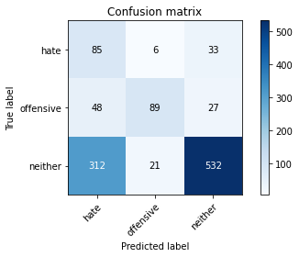

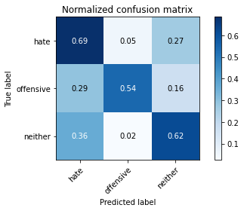

precision recall f1-score support

hate 0.19 0.69 0.30 124

offensive 0.77 0.54 0.64 164

neither 0.90 0.62 0.73 865

accuracy 0.61 1153

macro avg 0.62 0.61 0.55 1153

weighted avg 0.80 0.61 0.67 1153

average eval_loss: 0.9292594389668827, accuracy: 0.6123156981786644

training 5 epoch...

137.61396408081055 seconds used......

5 training finished! average train loss: 0.22732827189432475

evaluating...

Confusion matrix, without normalization

[[ 62 8 54]

[ 38 83 43]

[159 28 678]]

Normalized confusion matrix

[[0.5 0.06451613 0.43548387]

[0.23170732 0.50609756 0.26219512]

[0.18381503 0.03236994 0.78381503]]

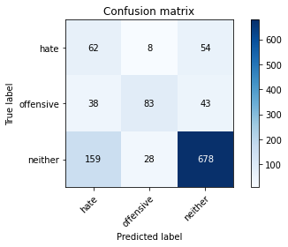

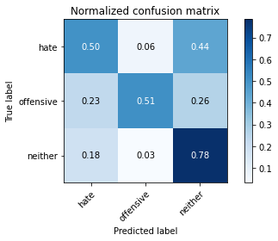

precision recall f1-score support

hate 0.24 0.50 0.32 124

offensive 0.70 0.51 0.59 164

neither 0.87 0.78 0.83 865

accuracy 0.71 1153

macro avg 0.60 0.60 0.58 1153

weighted avg 0.78 0.71 0.74 1153

average eval_loss: 0.905842043716332, accuracy: 0.7137901127493496

2 run......

training 1 epoch...

137.5340485572815 seconds used......

1 training finished! average train loss: 0.8474200178738747

evaluating...

Confusion matrix, without normalization

[[ 12 2 110]

[ 13 56 95]

[ 11 3 851]]

Normalized confusion matrix

[[0.09677419 0.01612903 0.88709677]

[0.07926829 0.34146341 0.57926829]

[0.01271676 0.00346821 0.98381503]]

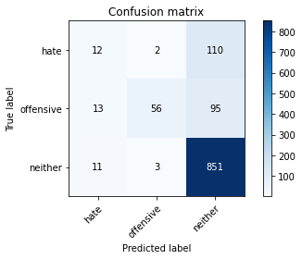

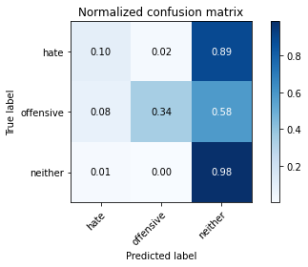

precision recall f1-score support

hate 0.33 0.10 0.15 124

offensive 0.92 0.34 0.50 164

neither 0.81 0.98 0.89 865

accuracy 0.80 1153

macro avg 0.69 0.47 0.51 1153

weighted avg 0.77 0.80 0.75 1153

average eval_loss: 0.6389184707197649, accuracy: 0.7970511708586296

training 2 epoch...

137.84149599075317 seconds used......

2 training finished! average train loss: 0.7268921574228046

evaluating...

Confusion matrix, without normalization

[[ 17 12 95]

[ 6 98 60]

[ 19 18 828]]

Normalized confusion matrix

[[0.13709677 0.09677419 0.76612903]

[0.03658537 0.59756098 0.36585366]

[0.02196532 0.02080925 0.95722543]]

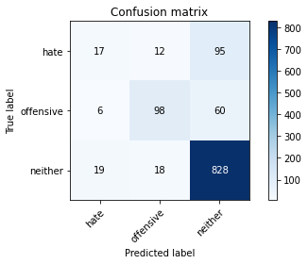

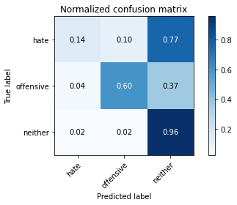

precision recall f1-score support

hate 0.40 0.14 0.20 124

offensive 0.77 0.60 0.67 164

neither 0.84 0.96 0.90 865

accuracy 0.82 1153

macro avg 0.67 0.56 0.59 1153

weighted avg 0.78 0.82 0.79 1153

average eval_loss: 0.5379363449996916, accuracy: 0.8178664353859497

training 3 epoch...

137.66397714614868 seconds used......

3 training finished! average train loss: 0.5902207531416376

evaluating...

Confusion matrix, without normalization

[[ 65 10 49]

[ 25 101 38]

[158 26 681]]

Normalized confusion matrix

[[0.52419355 0.08064516 0.39516129]

[0.15243902 0.61585366 0.23170732]

[0.18265896 0.0300578 0.78728324]]

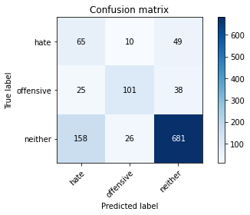

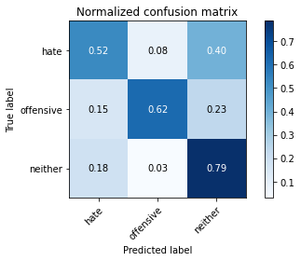

precision recall f1-score support

hate 0.26 0.52 0.35 124

offensive 0.74 0.62 0.67 164

neither 0.89 0.79 0.83 865

accuracy 0.73 1153

macro avg 0.63 0.64 0.62 1153

weighted avg 0.80 0.73 0.76 1153

average eval_loss: 0.6715029544871429, accuracy: 0.7346053772766695

training 4 epoch...

137.72646689414978 seconds used......

4 training finished! average train loss: 0.35282762341023305

evaluating...

Confusion matrix, without normalization

[[ 42 18 64]

[ 12 104 48]

[ 75 25 765]]

Normalized confusion matrix

[[0.33870968 0.14516129 0.51612903]

[0.07317073 0.63414634 0.29268293]

[0.0867052 0.02890173 0.88439306]]

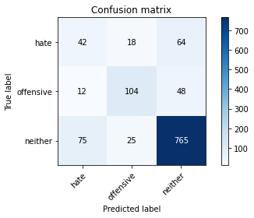

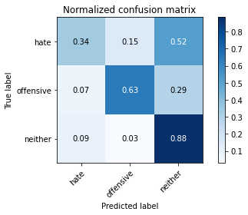

precision recall f1-score support

hate 0.33 0.34 0.33 124

offensive 0.71 0.63 0.67 164

neither 0.87 0.88 0.88 865

accuracy 0.79 1153

macro avg 0.64 0.62 0.63 1153

weighted avg 0.79 0.79 0.79 1153

average eval_loss: 0.6472856160895578, accuracy: 0.790112749349523

training 5 epoch...

137.59677124023438 seconds used......

5 training finished! average train loss: 0.18346824369205753

evaluating...

Confusion matrix, without normalization

[[ 51 10 63]

[ 20 98 46]

[139 29 697]]

Normalized confusion matrix

[[0.41129032 0.08064516 0.50806452]

[0.12195122 0.59756098 0.2804878 ]

[0.16069364 0.03352601 0.80578035]]

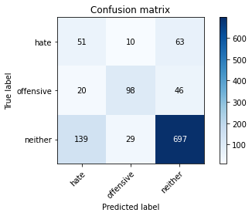

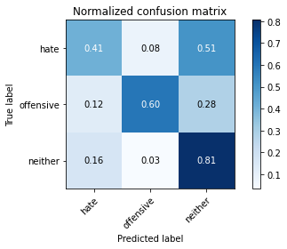

precision recall f1-score support

hate 0.24 0.41 0.31 124

offensive 0.72 0.60 0.65 164

neither 0.86 0.81 0.83 865

accuracy 0.73 1153

macro avg 0.61 0.60 0.60 1153

weighted avg 0.78 0.73 0.75 1153

average eval_loss: 0.8389566006331608, accuracy: 0.7337380745880312

3 run......

training 1 epoch...

137.481707572937 seconds used......

1 training finished! average train loss: 0.8437585709648328

evaluating...

Confusion matrix, without normalization

[[ 11 14 99]

[ 6 104 54]

[ 15 39 811]]

Normalized confusion matrix

[[0.08870968 0.11290323 0.7983871 ]

[0.03658537 0.63414634 0.32926829]

[0.01734104 0.04508671 0.93757225]]

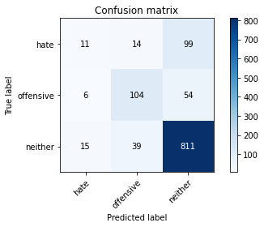

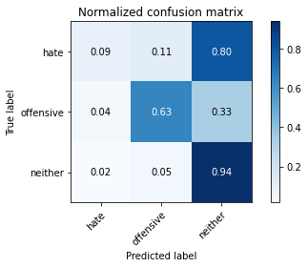

precision recall f1-score support

hate 0.34 0.09 0.14 124

offensive 0.66 0.63 0.65 164

neither 0.84 0.94 0.89 865

accuracy 0.80 1153

macro avg 0.62 0.55 0.56 1153

weighted avg 0.76 0.80 0.77 1153

average eval_loss: 0.6769480258226395, accuracy: 0.803122289679098

training 2 epoch...

137.4115629196167 seconds used......

2 training finished! average train loss: 0.7323674248347103

evaluating...

Confusion matrix, without normalization

[[ 59 5 60]

[ 27 86 51]

[ 92 9 764]]

Normalized confusion matrix

[[0.47580645 0.04032258 0.48387097]

[0.16463415 0.52439024 0.31097561]

[0.10635838 0.01040462 0.88323699]]

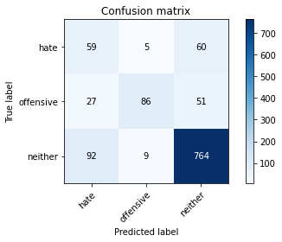

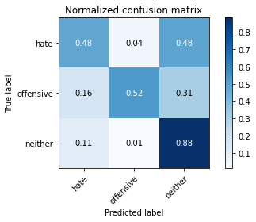

precision recall f1-score support

hate 0.33 0.48 0.39 124

offensive 0.86 0.52 0.65 164

neither 0.87 0.88 0.88 865

accuracy 0.79 1153

macro avg 0.69 0.63 0.64 1153

weighted avg 0.81 0.79 0.79 1153

average eval_loss: 0.6070568710565567, accuracy: 0.7883781439722463

training 3 epoch...

137.34647917747498 seconds used......

3 training finished! average train loss: 0.5854440895974026

evaluating...

Confusion matrix, without normalization

[[ 82 19 23]

[ 38 105 21]

[209 48 608]]

Normalized confusion matrix

[[0.66129032 0.15322581 0.18548387]

[0.23170732 0.6402439 0.12804878]

[0.2416185 0.05549133 0.70289017]]

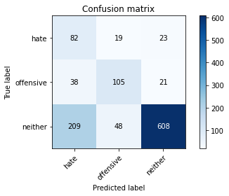

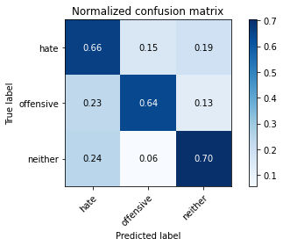

precision recall f1-score support

hate 0.25 0.66 0.36 124

offensive 0.61 0.64 0.62 164

neither 0.93 0.70 0.80 865

accuracy 0.69 1153

macro avg 0.60 0.67 0.60 1153

weighted avg 0.81 0.69 0.73 1153

average eval_loss: 0.7465361510885173, accuracy: 0.6895056374674762

training 4 epoch...

137.38391637802124 seconds used......

4 training finished! average train loss: 0.35865423912277805

evaluating...

Confusion matrix, without normalization

[[ 45 13 66]

[ 23 91 50]

[ 89 34 742]]

Normalized confusion matrix

[[0.36290323 0.10483871 0.53225806]

[0.1402439 0.55487805 0.30487805]

[0.10289017 0.03930636 0.85780347]]

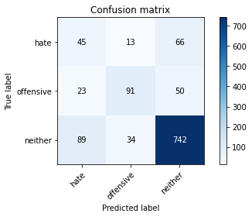

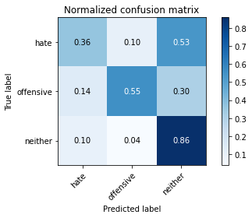

precision recall f1-score support

hate 0.29 0.36 0.32 124

offensive 0.66 0.55 0.60 164

neither 0.86 0.86 0.86 865

accuracy 0.76 1153

macro avg 0.60 0.59 0.59 1153

weighted avg 0.77 0.76 0.77 1153

average eval_loss: 0.6887552356668587, accuracy: 0.7614917606244579

training 5 epoch...

137.33644151687622 seconds used......

5 training finished! average train loss: 0.18248438337379144

evaluating...

Confusion matrix, without normalization

[[ 47 17 60]

[ 23 94 47]

[117 39 709]]

Normalized confusion matrix

[[0.37903226 0.13709677 0.48387097]

[0.1402439 0.57317073 0.28658537]

[0.13526012 0.04508671 0.81965318]]

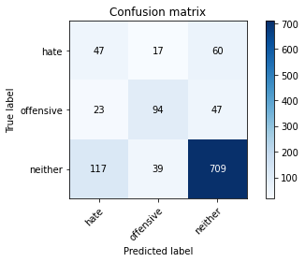

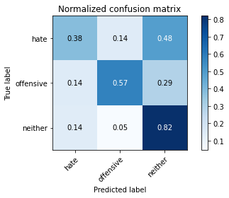

precision recall f1-score support

hate 0.25 0.38 0.30 124

offensive 0.63 0.57 0.60 164

neither 0.87 0.82 0.84 865

accuracy 0.74 1153

macro avg 0.58 0.59 0.58 1153

weighted avg 0.77 0.74 0.75 1153

average eval_loss: 0.861241113009124, accuracy: 0.7372072853425846

4 run......

training 1 epoch...

137.29690504074097 seconds used......

1 training finished! average train loss: 0.8493522055726817

evaluating...

Confusion matrix, without normalization

[[ 43 12 69]

[ 15 93 56]

[ 50 12 803]]

Normalized confusion matrix

[[0.34677419 0.09677419 0.55645161]

[0.09146341 0.56707317 0.34146341]

[0.05780347 0.01387283 0.9283237 ]]

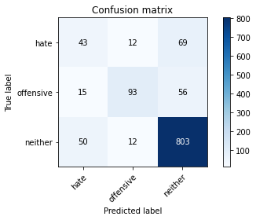

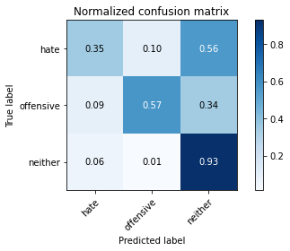

precision recall f1-score support

hate 0.40 0.35 0.37 124

offensive 0.79 0.57 0.66 164

neither 0.87 0.93 0.90 865

accuracy 0.81 1153

macro avg 0.69 0.61 0.64 1153

weighted avg 0.81 0.81 0.81 1153

average eval_loss: 0.6589813725701694, accuracy: 0.8143972246313964

training 2 epoch...

137.28948521614075 seconds used......

2 training finished! average train loss: 0.725199141803455

evaluating...

Confusion matrix, without normalization

[[ 54 24 46]

[ 17 115 32]

[102 37 726]]

Normalized confusion matrix

[[0.43548387 0.19354839 0.37096774]

[0.10365854 0.70121951 0.19512195]

[0.11791908 0.04277457 0.83930636]]

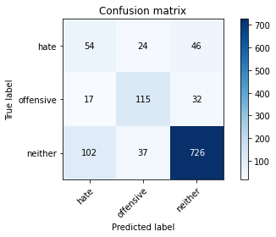

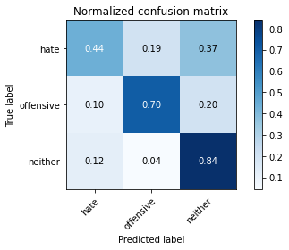

precision recall f1-score support

hate 0.31 0.44 0.36 124

offensive 0.65 0.70 0.68 164

neither 0.90 0.84 0.87 865

accuracy 0.78 1153

macro avg 0.62 0.66 0.64 1153

weighted avg 0.80 0.78 0.79 1153

average eval_loss: 0.6287818186242005, accuracy: 0.7762359063313097

training 3 epoch...

137.55803108215332 seconds used......

3 training finished! average train loss: 0.583148072248026

evaluating...

Confusion matrix, without normalization

[[ 47 17 60]

[ 21 109 34]

[107 30 728]]

Normalized confusion matrix

[[0.37903226 0.13709677 0.48387097]

[0.12804878 0.66463415 0.20731707]

[0.12369942 0.03468208 0.8416185 ]]

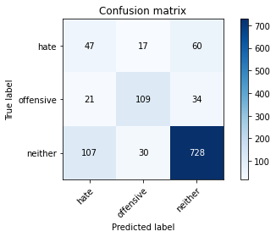

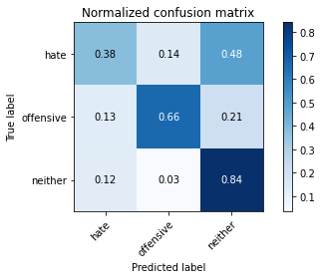

precision recall f1-score support

hate 0.27 0.38 0.31 124

offensive 0.70 0.66 0.68 164

neither 0.89 0.84 0.86 865

accuracy 0.77 1153

macro avg 0.62 0.63 0.62 1153

weighted avg 0.79 0.77 0.78 1153

average eval_loss: 0.5894927593140766, accuracy: 0.766695576756288

training 4 epoch...

137.4686541557312 seconds used......

4 training finished! average train loss: 0.34768087345687193

evaluating...

Confusion matrix, without normalization

[[ 81 7 36]

[ 38 90 36]

[200 22 643]]

Normalized confusion matrix

[[0.65322581 0.05645161 0.29032258]

[0.23170732 0.54878049 0.2195122 ]

[0.23121387 0.02543353 0.7433526 ]]

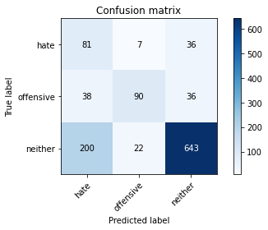

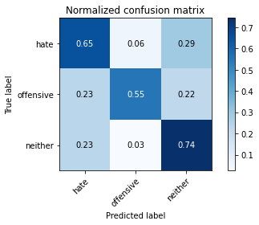

precision recall f1-score support

hate 0.25 0.65 0.37 124

offensive 0.76 0.55 0.64 164

neither 0.90 0.74 0.81 865

accuracy 0.71 1153

macro avg 0.64 0.65 0.61 1153

weighted avg 0.81 0.71 0.74 1153

average eval_loss: 0.8014245716662243, accuracy: 0.7059843885516045

training 5 epoch...

137.4593324661255 seconds used......

5 training finished! average train loss: 0.1652925784092511

evaluating...

Confusion matrix, without normalization

[[ 72 14 38]

[ 30 102 32]

[179 37 649]]

Normalized confusion matrix

[[0.58064516 0.11290323 0.30645161]

[0.18292683 0.62195122 0.19512195]

[0.20693642 0.04277457 0.75028902]]

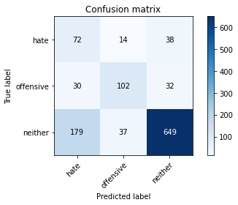

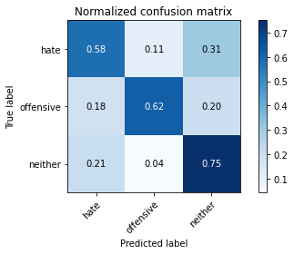

precision recall f1-score support

hate 0.26 0.58 0.36 124

offensive 0.67 0.62 0.64 164

neither 0.90 0.75 0.82 865

accuracy 0.71 1153

macro avg 0.61 0.65 0.61 1153

weighted avg 0.80 0.71 0.74 1153

average eval_loss: 0.9387965541461418, accuracy: 0.7137901127493496

5 run......

training 1 epoch...

137.55532550811768 seconds used......

1 training finished! average train loss: 0.8421047266839714

evaluating...

Confusion matrix, without normalization

[[ 14 9 101]

[ 4 79 81]

[ 23 9 833]]

Normalized confusion matrix

[[0.11290323 0.07258065 0.81451613]

[0.02439024 0.48170732 0.49390244]

[0.0265896 0.01040462 0.96300578]]

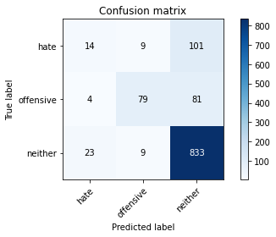

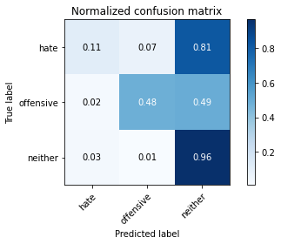

precision recall f1-score support

hate 0.34 0.11 0.17 124

offensive 0.81 0.48 0.61 164

neither 0.82 0.96 0.89 865

accuracy 0.80 1153

macro avg 0.66 0.52 0.55 1153

weighted avg 0.77 0.80 0.77 1153

average eval_loss: 0.6489272713661194, accuracy: 0.803122289679098

training 2 epoch...

137.55921578407288 seconds used......

2 training finished! average train loss: 0.7332212920888699

evaluating...

Confusion matrix, without normalization

[[ 16 11 97]

[ 6 104 54]

[ 24 25 816]]

Normalized confusion matrix

[[0.12903226 0.08870968 0.78225806]

[0.03658537 0.63414634 0.32926829]

[0.02774566 0.02890173 0.9433526 ]]

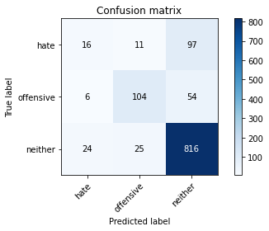

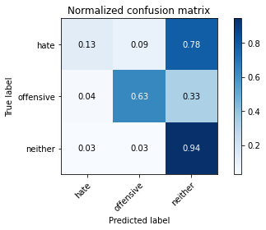

precision recall f1-score support

hate 0.35 0.13 0.19 124

offensive 0.74 0.63 0.68 164

neither 0.84 0.94 0.89 865

accuracy 0.81 1153

macro avg 0.64 0.57 0.59 1153

weighted avg 0.78 0.81 0.79 1153

average eval_loss: 0.5663592517375946, accuracy: 0.8117953165654813

training 3 epoch...

137.5913782119751 seconds used......

3 training finished! average train loss: 0.5971582375797395

evaluating...

Confusion matrix, without normalization

[[ 43 10 71]

[ 15 101 48]

[ 98 22 745]]

Normalized confusion matrix

[[0.34677419 0.08064516 0.57258065]

[0.09146341 0.61585366 0.29268293]

[0.1132948 0.02543353 0.86127168]]

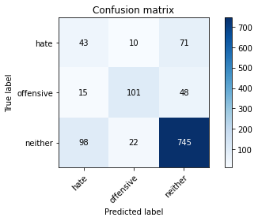

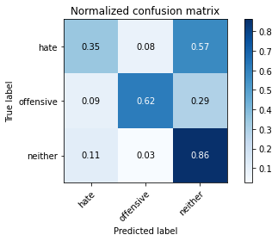

precision recall f1-score support

hate 0.28 0.35 0.31 124

offensive 0.76 0.62 0.68 164

neither 0.86 0.86 0.86 865

accuracy 0.77 1153

macro avg 0.63 0.61 0.62 1153

weighted avg 0.78 0.77 0.78 1153

average eval_loss: 0.6350510875726568, accuracy: 0.7710320901994796

training 4 epoch...

137.46187591552734 seconds used......

4 training finished! average train loss: 0.3826933665131139

evaluating...

Confusion matrix, without normalization

[[ 54 8 62]

[ 25 85 54]

[132 22 711]]

Normalized confusion matrix

[[0.43548387 0.06451613 0.5 ]

[0.15243902 0.51829268 0.32926829]

[0.15260116 0.02543353 0.82196532]]

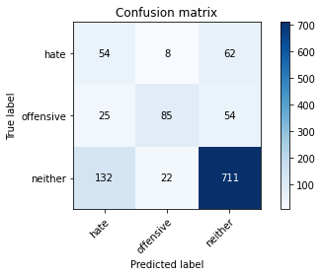

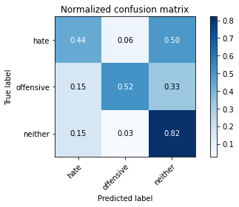

precision recall f1-score support

hate 0.26 0.44 0.32 124

offensive 0.74 0.52 0.61 164

neither 0.86 0.82 0.84 865

accuracy 0.74 1153

macro avg 0.62 0.59 0.59 1153

weighted avg 0.78 0.74 0.75 1153

average eval_loss: 0.7907837935048958, accuracy: 0.7372072853425846

training 5 epoch...

137.51664876937866 seconds used......

5 training finished! average train loss: 0.19616855299513494

evaluating...

Confusion matrix, without normalization

[[ 69 7 48]

[ 35 90 39]

[198 26 641]]

Normalized confusion matrix

[[0.55645161 0.05645161 0.38709677]

[0.21341463 0.54878049 0.23780488]

[0.22890173 0.0300578 0.74104046]]

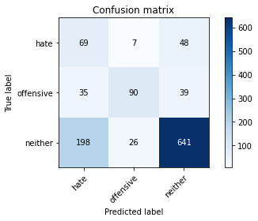

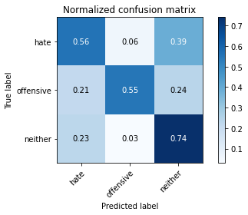

precision recall f1-score support

hate 0.23 0.56 0.32 124

offensive 0.73 0.55 0.63 164

neither 0.88 0.74 0.80 865

accuracy 0.69 1153

macro avg 0.61 0.62 0.59 1153

weighted avg 0.79 0.69 0.73 1153

average eval_loss: 1.0926582869784585, accuracy: 0.6938421509106678